# Question-1

1. D) Make sure all bonds are ticked in edit bond

e) select option, then press delete in keyboard; or use right bar

f) Indium locations:

1. (0,0,0)
2. 10.48059 0.00000 0.00000
3. 5.24030 5.24030 0.00000
4. 5.24030 10.48059 5.24030
5. 10.48059 5.24030 5.24030
6. 10.48059 0.00000 10.48059
7. 10.48059 10.48059 0.00000
8. 10.48059 10.48059 10.48059
9. 10.48059 0.00000 10.48059
10. 5.24030 5.24030 10.48059
11. 0.00000 0.00000 10.48059
12. 0.00000 10.48059 10.48059
13. 0.00000 5.24030 5.24030
14. 0.00000 10.48059 0.00000
15. 5.24030 10.48059 5.24030
16. 5.24030 0.00000 5.24030

Silver locations:

1. 10.48059 0.00000 5.24030
2. 0.00000 0.00000 5.24030
3. 0.00000 10.48059 5.24030
4. 10.48059 10.48059 5.24030
5. 0.0000 5.24030 0.00000
6. 0.0000 5.24030 10.48059
7. 10.48059 5.24030 10.48059
8. 10.48059 5.24030 0.00000
9. 5.24030 0.00000 10.48059
10. 5.24030 10.48059 0.00000
11. 5.24030 10.48059 0.00000
12. 5.24030 0.00000 0.00000
13. 5.24030 5.24030 5.24030

Cs locations:

1. 2.62015 2.62015 2.62015
2. 7.86044 2.62015 2.62015
3. 7.86044 2.62015 7.86044
4. 2.62015 2.62015 7.86044

g)

Yes, all planes have In in corners and centre. Silver in edge centres. Chlorine atoms in between In and Ag parallel to edges.

h)

red: 010 and 0-10

yellow: 001 and 00 -1

cyan: 100 and -100

i)

(101): no bonds

l(In-Cl) = 2.507(8) Å

l(Ag-Cl) = 2.733(8) Å

all bonds look like 90 degrees

# Question 2

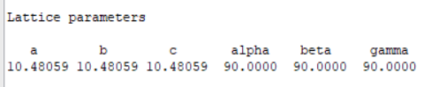

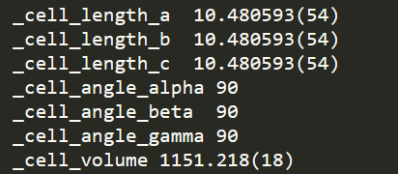

Space group:**Fm-3m**

1. F lattice
2. Mirror along a-axis
3. C3 axis along b-axis with inversion
4. Mirror along c-axis

b)

225

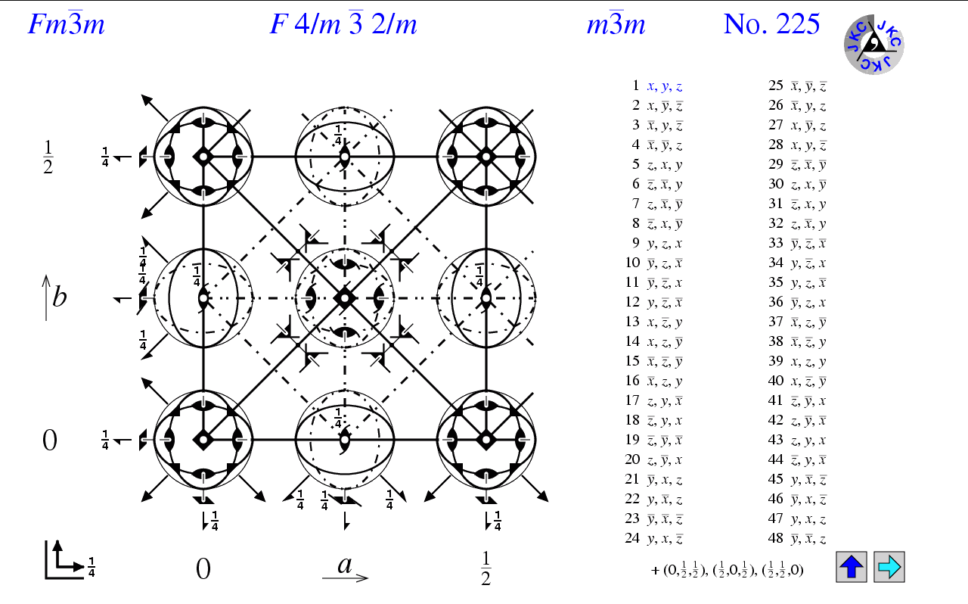

<http://img.chem.ucl.ac.uk/sgp/misc/symbols.htm>

# Question 4

